NDHU

Event System

Sofia Lopez Ayala | 410321161

Andres Obregon Martinez | 410321166

Foreword

NDHU Event System is about the process, knowledge, technologies and a step-by-step guide of what it took to Sofia and Andres to get this project done.

Through every stage of the current project, as developer of NDHU Event System, planning and time management skills have been developed along with the most important as communication between the two of us.

Since the beginning, we decided to discuss every decision to make at any stage. This is something that helped us to agree in what direction to take and also to contribute with ideas and ways to develop anything in NDHU Event System.

It has been an exciting journey that gave us the opportunity to learn new ways of web developing and also we could learned new technologies.

We would like to thank Professor 賴志宏 for trusting in us as a group and for always giving us support and for his advice on this journey.

Thanks to our friends for their support during the developing of this project.

Purpose

The purpose of this project “NDHU Event System” is to simplify the big amount of information managed for events in campus.

By using NDHU Event System, all the information regarding future and past activities will be centralized into this system allowing the user access to it at any time. For so many years, we have found out that students, foreign students most of them, do not go into the email system to look for any event information, cause there is so much information gathered together. We decided to develop a system aim only for all events in campus. It will also give opportunity to be part of any activity staff only to students of NDHU.

In this report, we will introduce and display how to use the different users that are allowed to get into NDHU Event System.

During developing this project, we intend to put all the knowledge acquired on the last for years of school and also at the same time, use our research skills on programming field to get all the information from Internet.

Through the following parts of the current report: Knowledge, methods, results and discussion, we will use a narrative approach for clearness purposes.

When developing NDHU Event System, we decided to code together, it means, to share every function on our to-do list. We aimed to learn from each other while developing so we both could improve our programming skills while developing.

Relevant

Background

Knowledge  
In order to systematically introduce NDHU Event System Knowledge section, it is divided into two main stages: Before and after.

Before NDHU Event System, while planning what it would be our DataBase, we did not have a full understanding of the complications and what we would call extensions of this project. Before NDHU Event System, the group of technologies that were planned to use were:

* HTML5
* CSS3
* Jquery
* Php
* Mysql

After we started to develop the front-end part, we realized that we could not start from scratch and needed a quick solution for basic functions so we could use less javascript and leave it to manage of data only. And this is when after discussing it, we decided to use Bootstrap 4 (front-end new technology). Afterwards, we finished one of the many changes to our DataBase design. So the next step is to start getting along with the information saved manually. We found out that a powerful tool in order to manage efficiently and in an easy way is Jquery, ajax and json data structure (background technologies adding). Back and Front End where added one to two technologies each.

Methods

When developing front and back end sections, we discussed from the beginning to keep both divided into files.

For the Back-end files, we have used files with php code only having the word “fetch” in their name also with “DB” at the end. These files have been specifically used to get all the queries from the front-end to the Database.

After catching the result of the query, we catch into an array, most of the time, and into a Json object so it can take back to the front-end, that we will see below that is directly taking it into the success or fail result of the Ajax method.

As an example of our back-end code section, we show left, one of the most common structure for the functions used on it. For security purposes, we have deleted database column names and data we consider not proper to display:

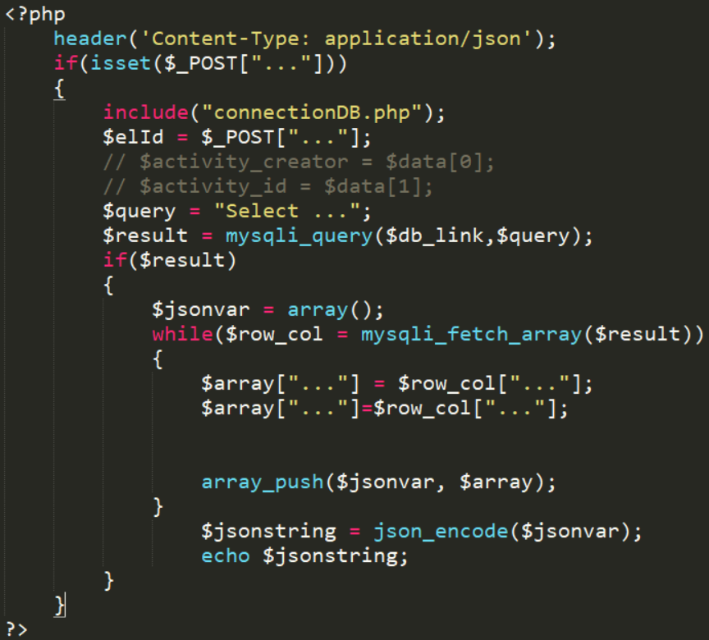

Above was shown the most common php & Json function structure used as a model for all the other functions used on this project. After information is caught and managed into a json array, it is sent to front-end file that contains html (as the visual structure and elements visibles for the user) with Jquery (code used to handled elements on html code and also to control the information sent from the back-end.

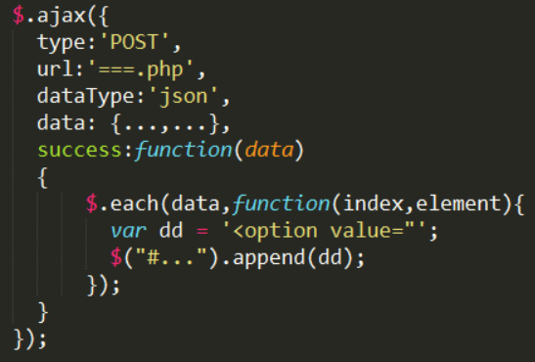

A basic structure of ajax function is shown on the right. For security purposes, data, parameters and variables have been deleted.

Every data is received as a success (it was designed that way to avoid the failed function).

Among the tools that we agreed when planning and after a few changes to the structure of NDHU Event System, are shown on the following picture and specifically there are two as “clockpicker” one as javascript and the left one as stylesheet that allows us to use the element style from jquery and also its functionalities in order to choose time for the activity. In the following picture, we show all the javascripts that part of them have been downloaded and save along with our php files and divided into different folders.

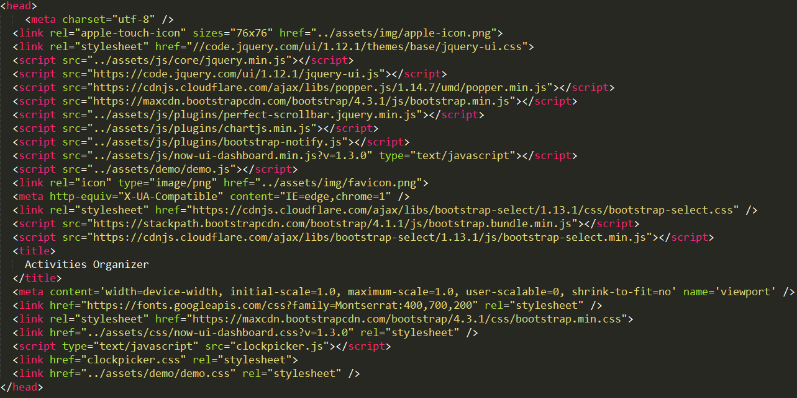

Data Base Design

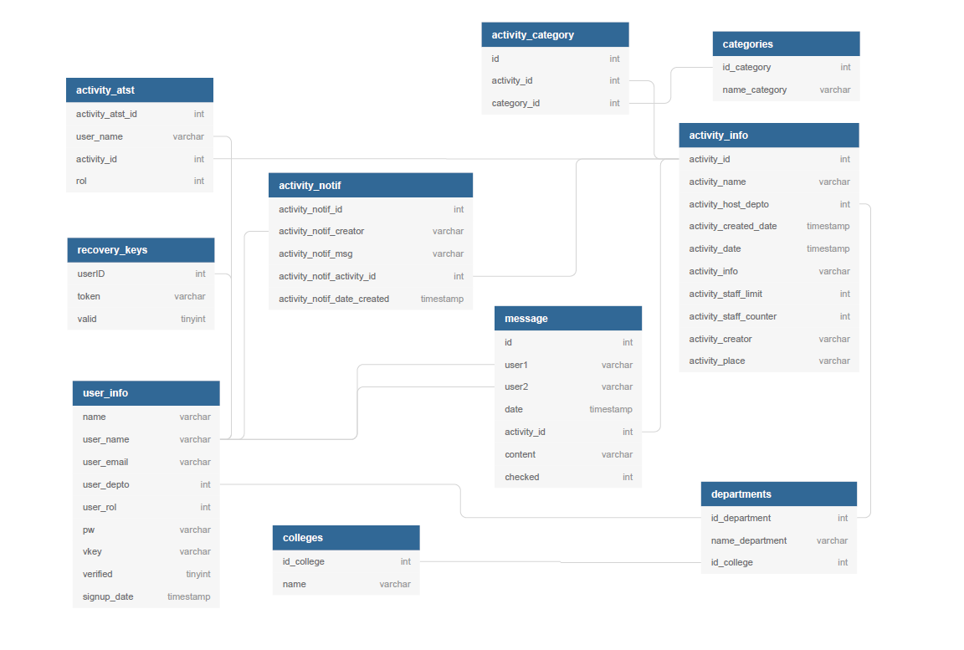

Our Data base counts with 10 tables in total. There is one table only for all the different categories for activities, also for all the colleges and departments in school, one table each.   
One more functionality that we have added to NDHU Event System is the use of Stored Procedures that help us out returning the ID of the data that we have just inserted in order to take the ID and save it into another table. Please look at the image below for reference (for security purposes, the following stored procedure has been modified)

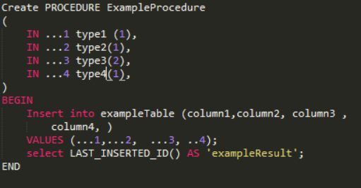

Results

We are excited to introduce a few screenshots of what has been our 4-months team work.

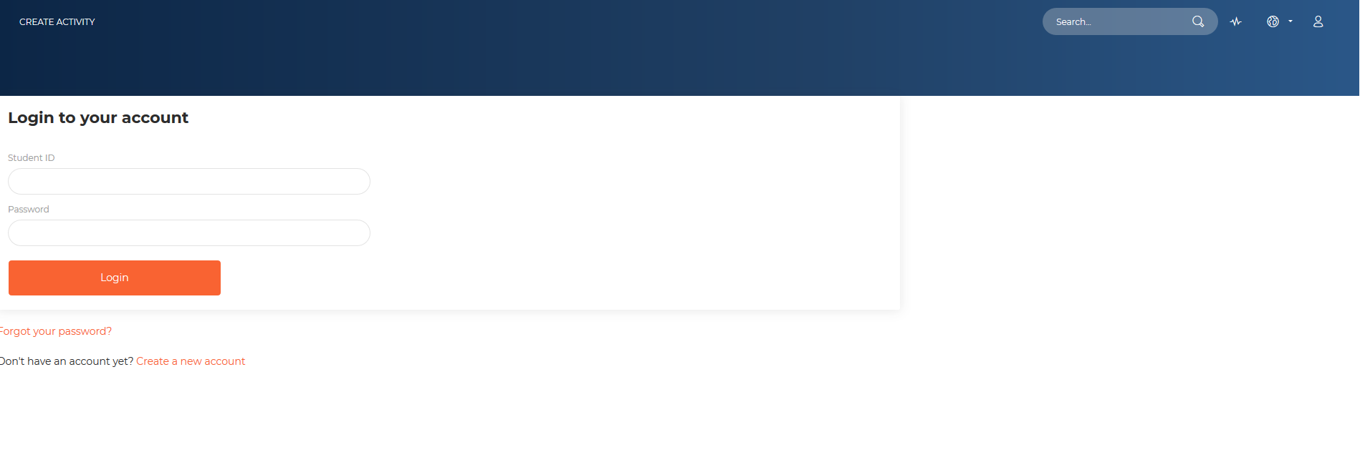

Firstly, we introduce the log in website (image above) that will allow users to make sure if the account used has been verified before. If not, an email will be sent to their emails ( @gms.ndhu.edu.tw email from school). After confirming account, access is given and log-in process takes places normally.

After logging in, automatically will head users to our next website that is called “dashboard”. Every webpage in our system, besides log in, counts with a vertical menu on the left. NDHU Event System have divided functionalities into users that are allowed to create new activities ( more functionalities come along with creating activities as creating announcements for it, editing it, etc.) and the second profile aimed for an average student in campus that can get all the information from any activity of user’s interest. Image below shows NDHU Event System Dashboard Web Page for users that are allowed to create new activities and announcements (they can also get in touch with students that want to be part of the staff team for the activity created; each activity has the option to set up the need of staff or not). Dashbord web page also shows the upcoming activities for the next few days.

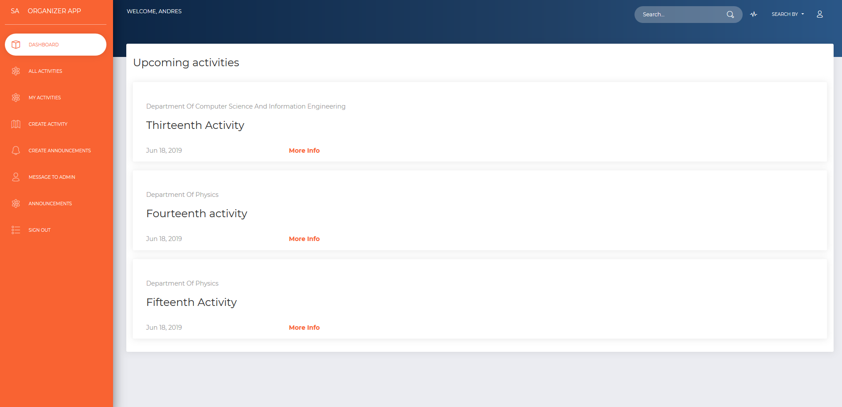

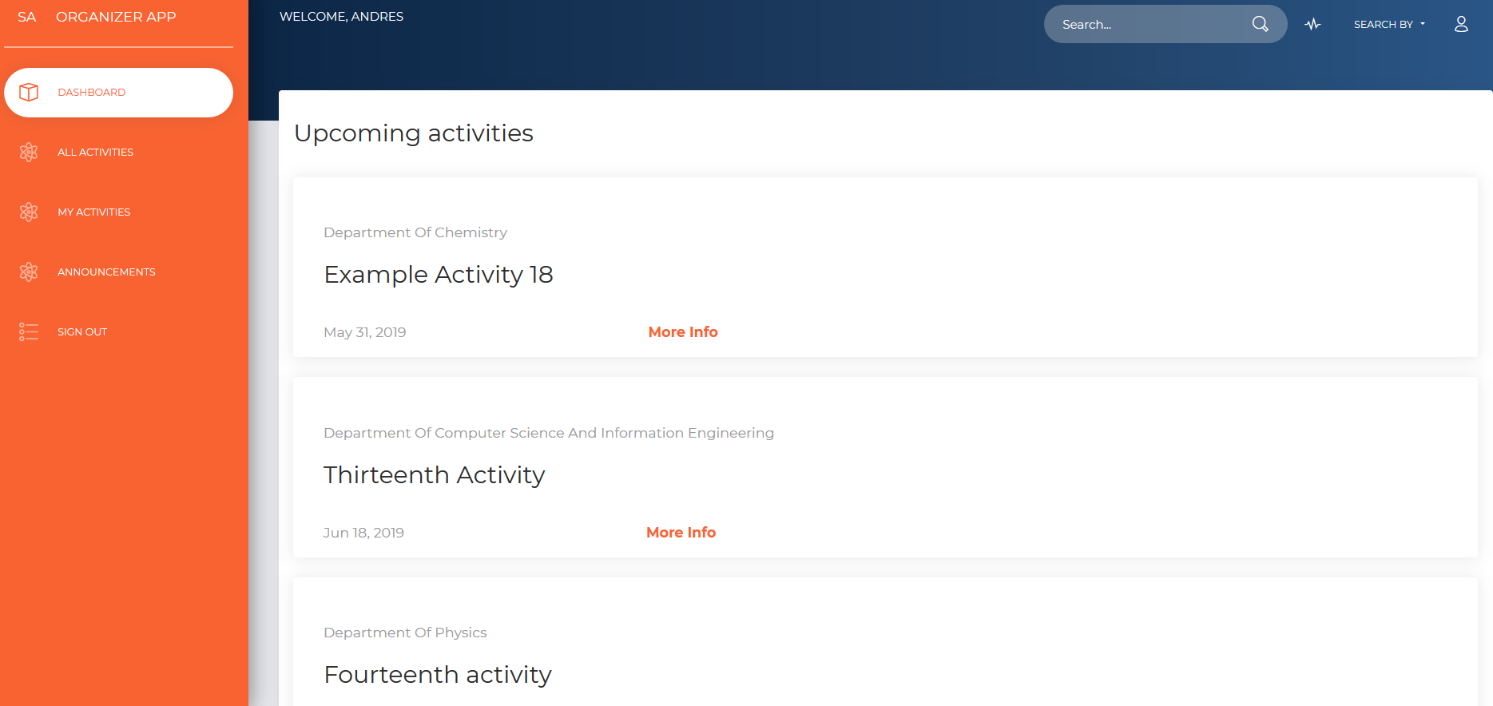

The difference among teachers and student profile is the functionalities available for each of them. For students, as it is shown above, “All activities”, “my activities” and “announcements” are also visible for students. “All activities” shows the list of all activities, “My activities” shows the list of activities that the student that has just logged in has sign for as staff member or only by attending the activity and “Announcements” are all the announcements in general for all the activities. Announcements are shown to every student no matter department nor college.

The first menu option on the left it is called “All activities” that shows all the activities that has passed already and the ones coming up. To make distinction of both, color red is used for the information displayed for activities that has passed already. Color black is used for activities that has not yet.

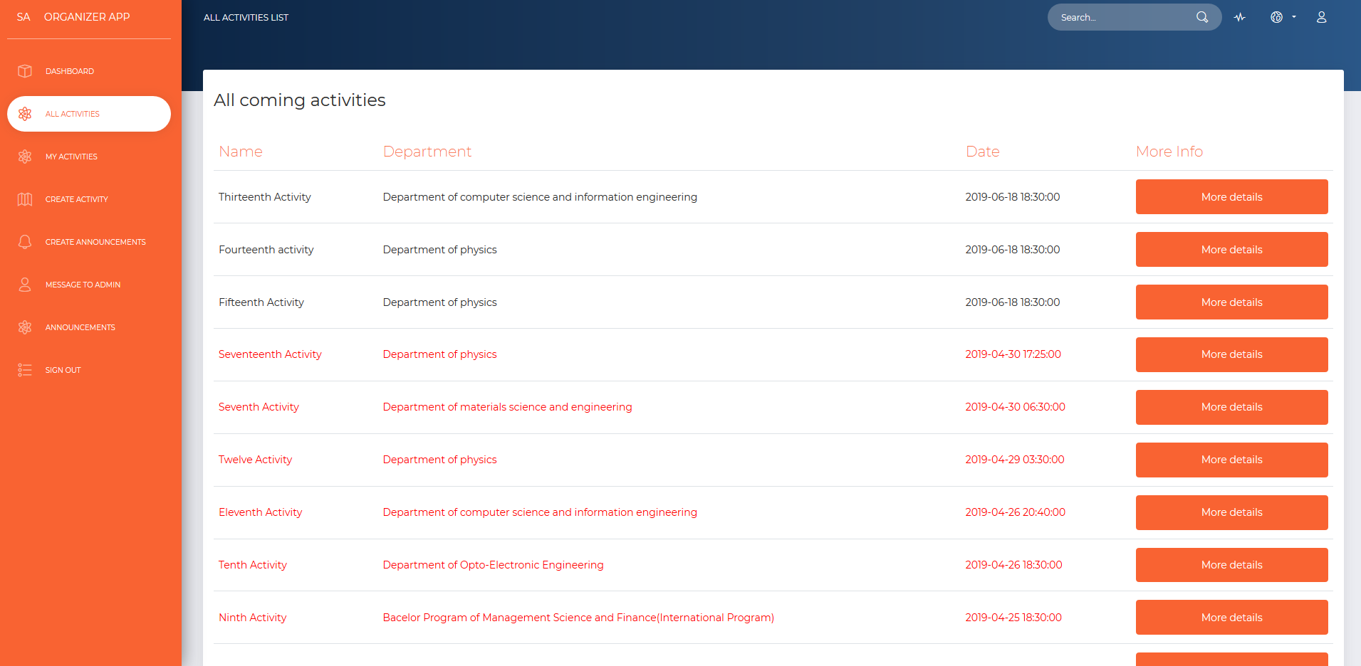

Every activity has a “More Info” column with an orange button on it that will take the user to a new webpage with all the info of the activity clicked on the last page.

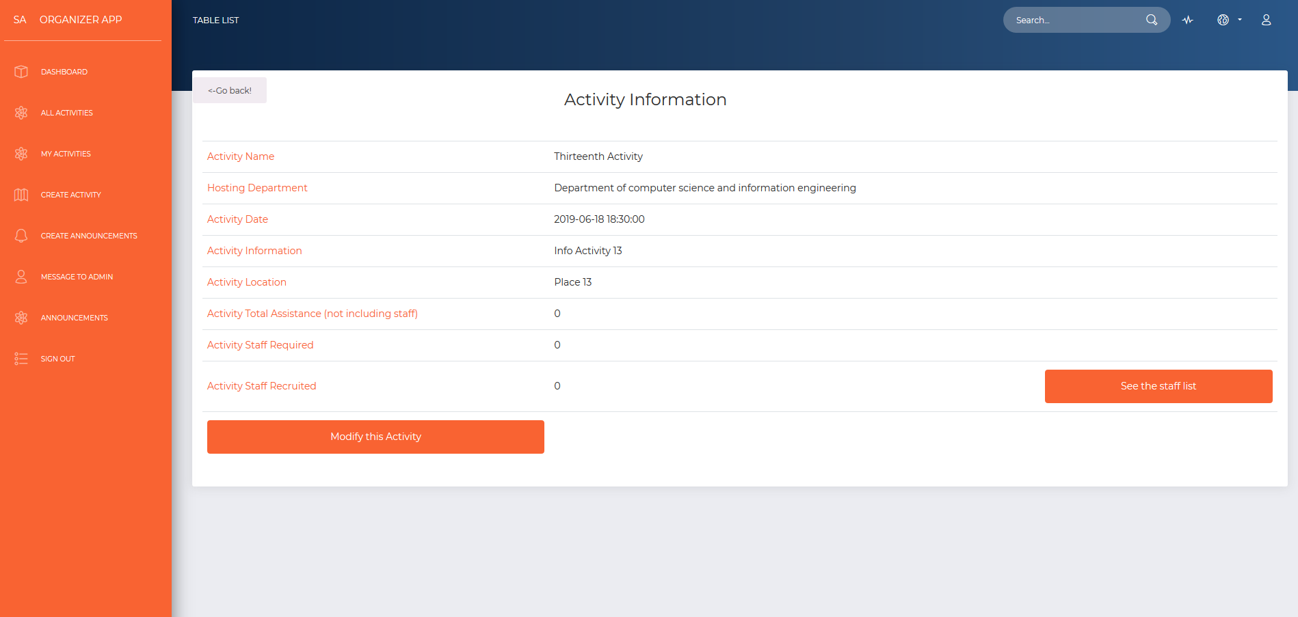

The image above shows the webpage that two different users will be sharing with one only difference: For the users that are allowed to create activities, if only if the activity the clicked on was created by them, two functions will show up on screen: the modify this activity and see the staff list buttons. For the users that did not create the activity they clicked on, the activity will detail will show as the following picture below:

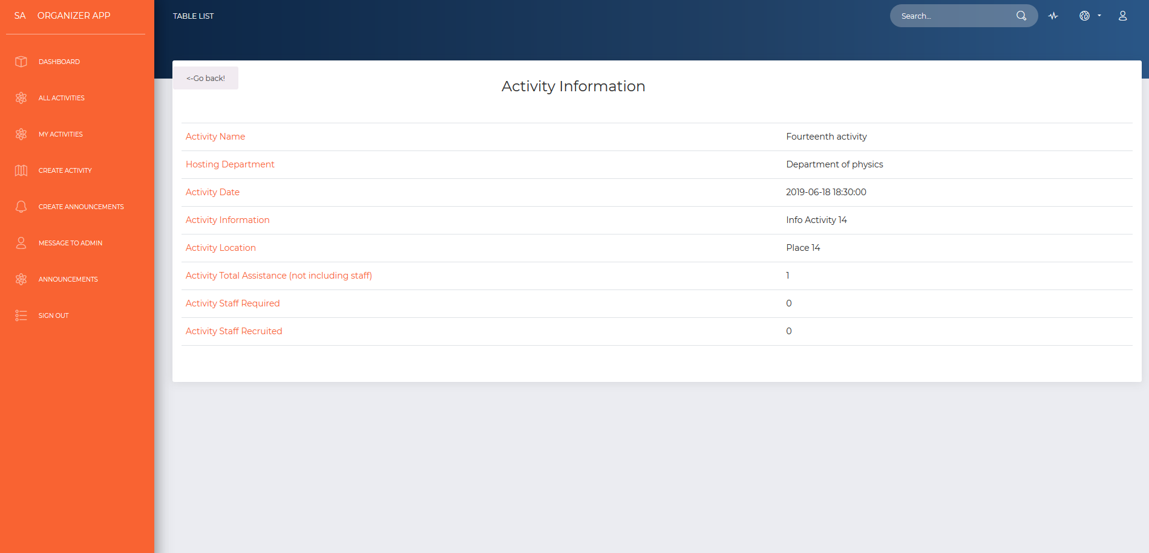

When the user wants to know more about any activity, and we know the user it is a student, the next web-page is not the ones showed in the last page. The work of verifying the user is done backstage and we redirect to the web-page shown above. There are a couple of new buttons and a different style. The student will be able to take a look to the announcements of the current activity by clicking on the red button called “Announcements” that will take the user to the list of announcements only for that activity, if any. In this case, this activity hasa not been taken place yet (2019-06-18) and another functionality that has been done backstage is verifying if the student has clicked on the “Attend” button. The “Attend” button it helps us to taking into account the number of people interested in attending this activity. If the user has done that before, the “Attend” button would not be enable; in that case the “Cancel” red button would be enable and “Attend” and “+Join Staff” button would be disabled. If the “staff required number is greater than 0, the “+join staff” yellow button would be enable. Student cannot set up the two buttons at the same time.

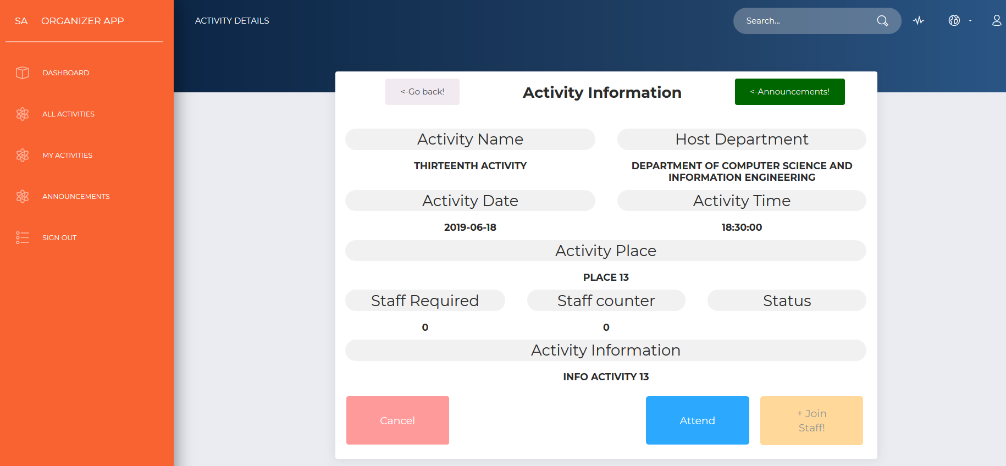

Regarding seeing the list of members for the staff, the image below picture how the creator of this activity can get in contact with the staff group by sending an email from his/her email. The system will automatically collect the email of the members of the staff, who will receive the email.

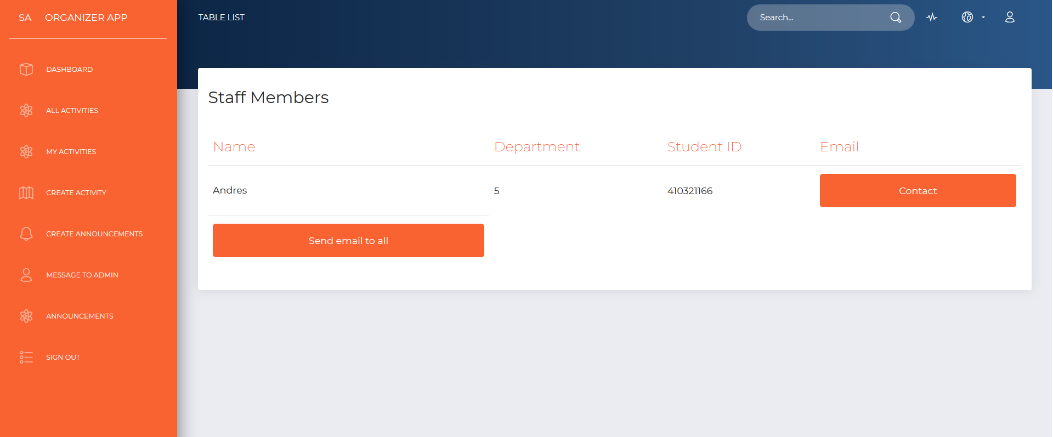

Right after getting access to Staff Members list, the “send email to all” button allows us to contact all the members at the same time. The staff members will get an email by the current user (person that have created the activity, as is shown below).

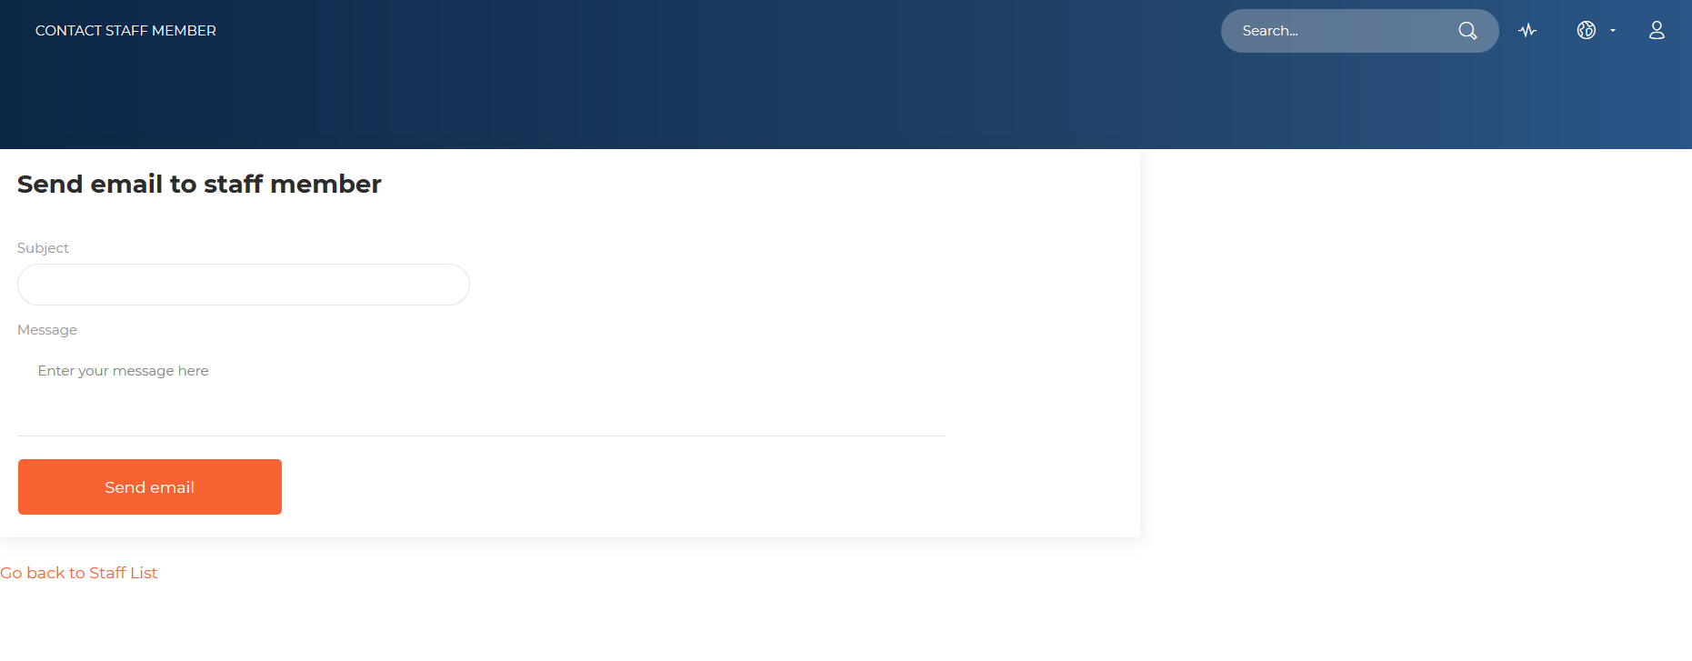

The following function on each activity details web-Page is to have access to edit the information. This function is available only for the creator of the current activity (the one selected from the all activities list. The image above shows what is shown on screen right after clicking on modify this activity button.

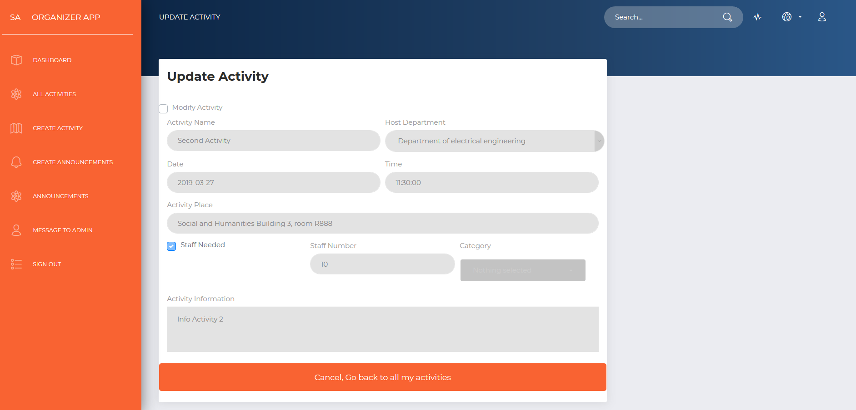

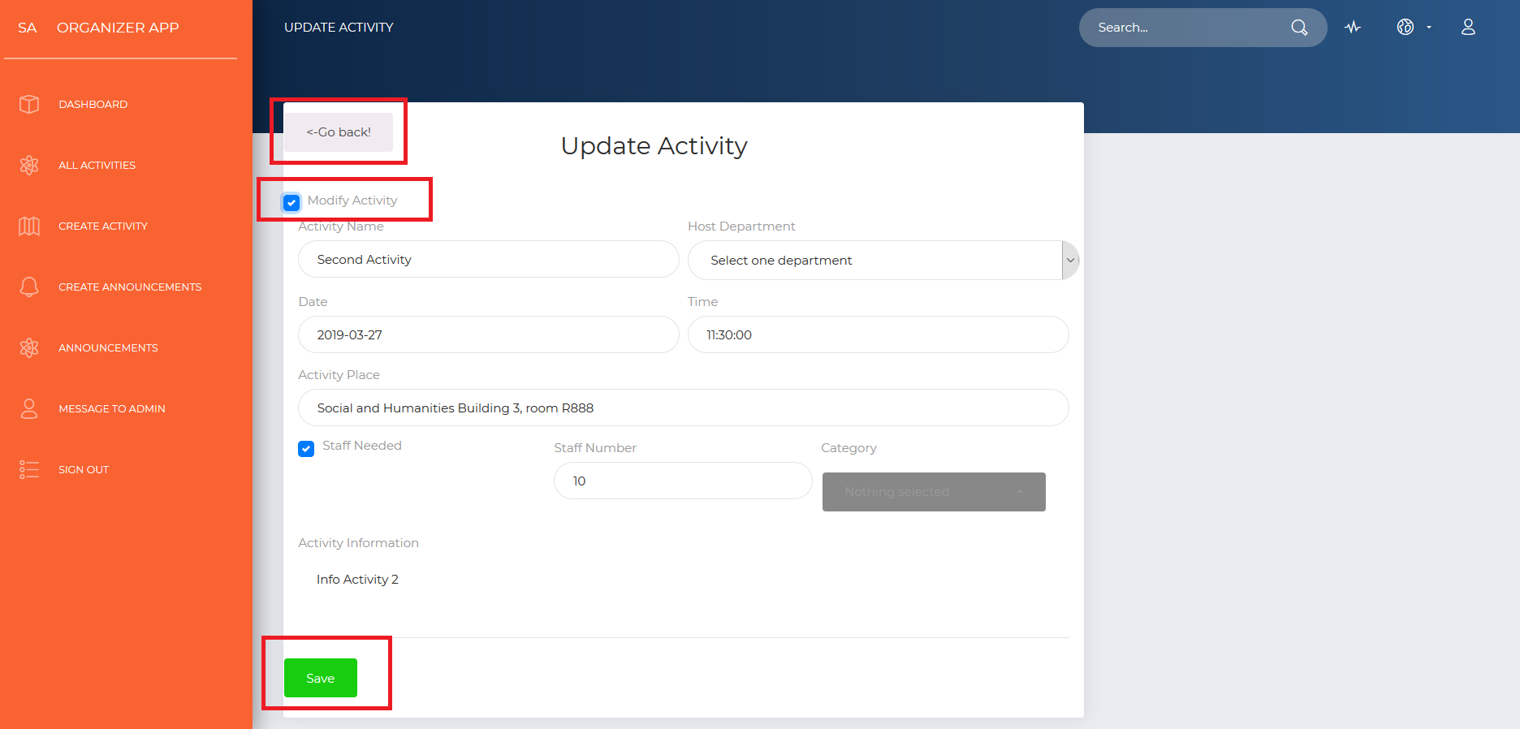

After clicking on “modify this activity”, the following web-page is a form with all the information already charged of that activity. After clicking on the “Modify Activity” checkbox, any information set up when creating it can be changed. There is also a button that will save any changes made in the information. If there is any change made but we do not want to save, in other words we would like to leave it as we found it, we click again on “modify activity” checkbox again.

The gray button that has been squared in red, takes us back to the web-page where the details of the activity are displayed. After making any change, click on “save” button, and changes will be made right away.

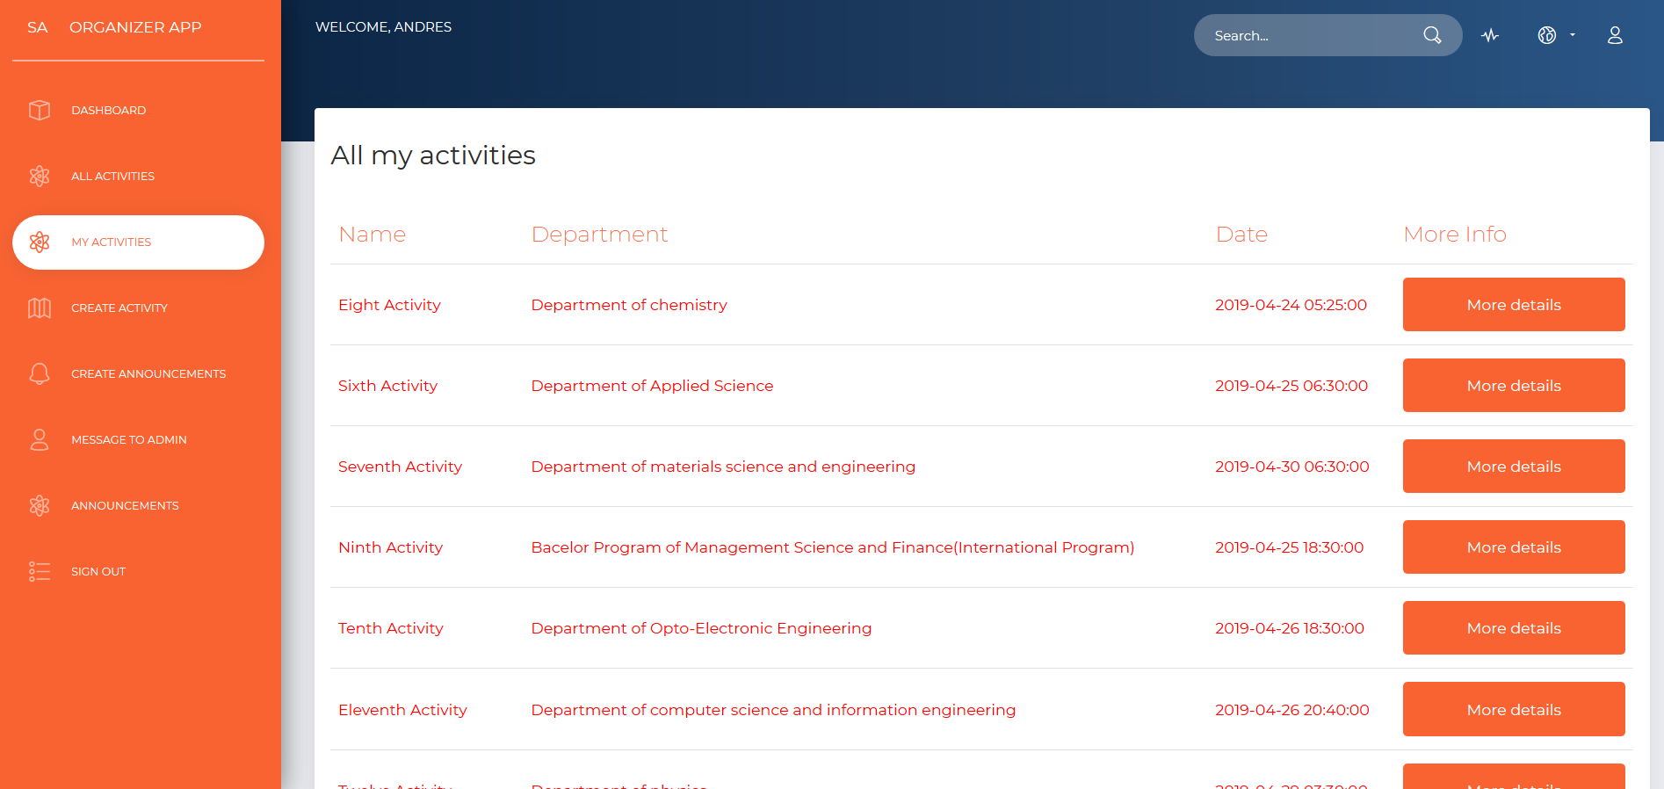

We also allow the user to display the activities that he/she has created before. The color red is used for the activities that has already taken place. As in the “All activities” section, “My activities” section also has the “more Info” column that has a “more details” button on it.

After clicking on the “More details” button, it redirects direct to the same web-page as with the button in “all activities” page.

For creating any activity at NDHU Event System, a couple of data is required to be filled as: Activity Name, Host Department (that will be chosen and no need to type it in), Activity Date (Chosen from a Jquery datepicker), time (also Chosen from a Jquery Clockpicker), activity place (the place where it will be held at), a check-box for staff (that not only tells us if staff will be needed but will also eliminate the ‘disabled’ attribute from the “staff number” HTML Input), staff number (if the checkbox was checked, category of the activity (more than one can be chosen) and a brief description of the activity.

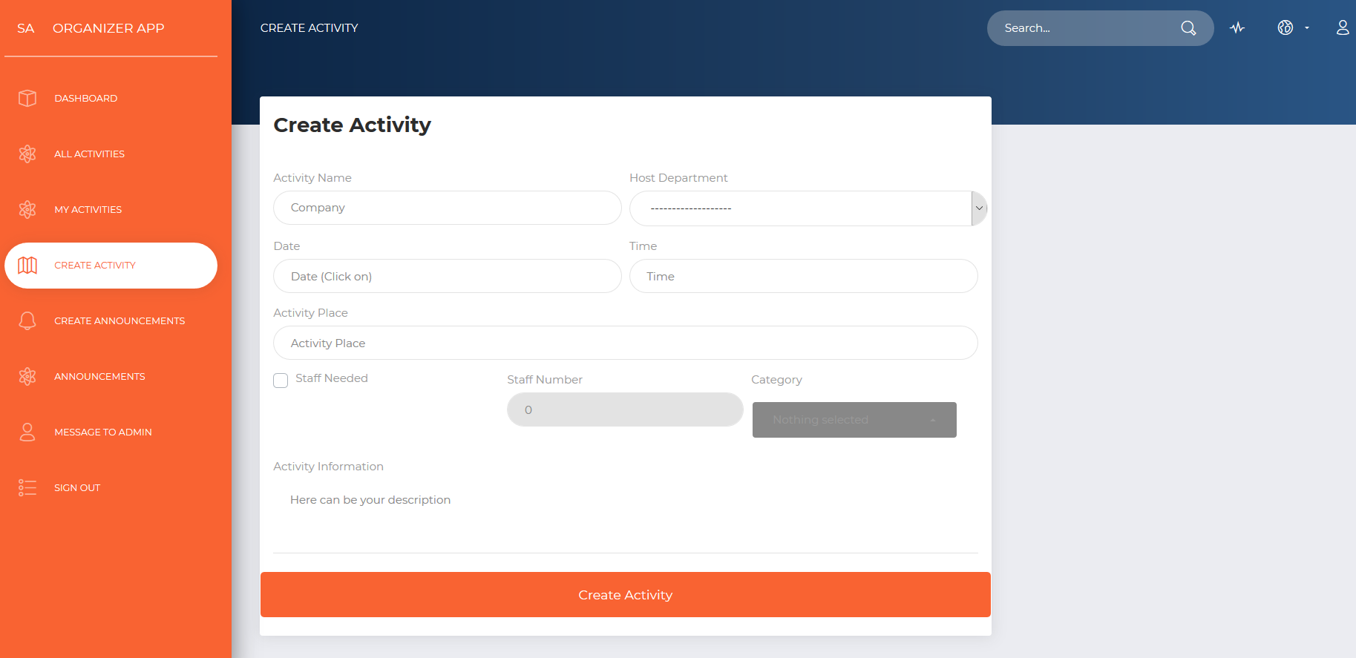

When filling up the new Activity Form, one HTML element that is quite different from the others in an average form is the datepicker. The calendar can be displayed only by clicking on any part of the Date input.

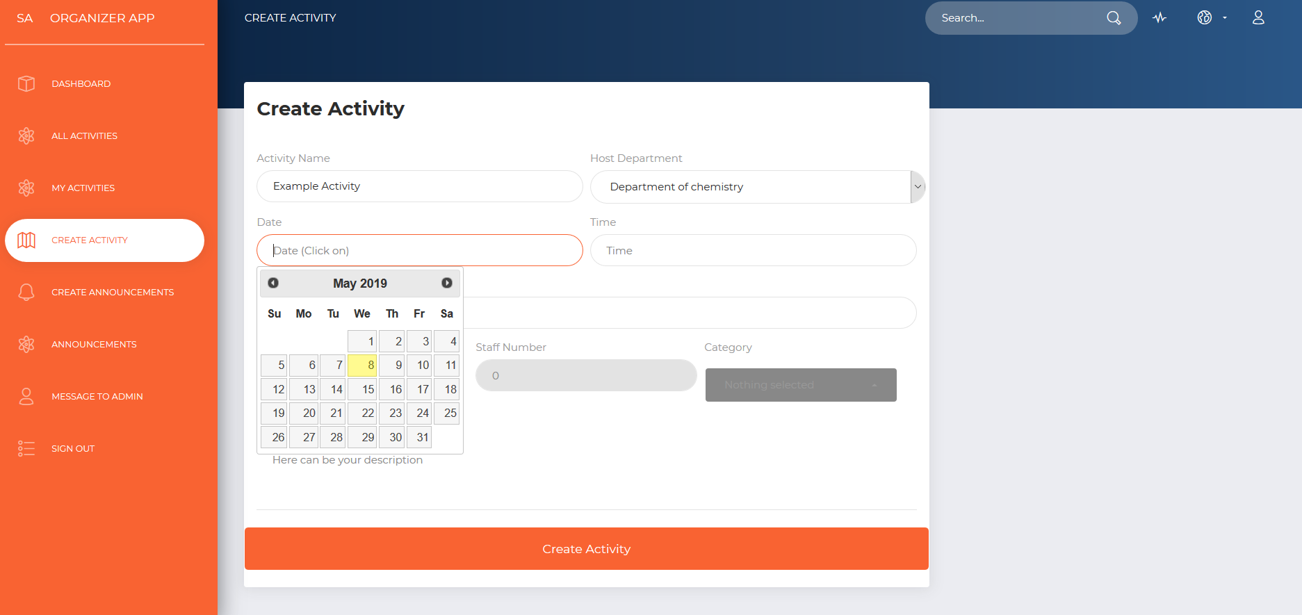

Activity time is a must when filing up all the information for the new activity. When choosing the hour, automatically minutes will show up on screen and we only need to click on the amount of minutes and finally click on the border at the inferior bottom of the clock pop-up.

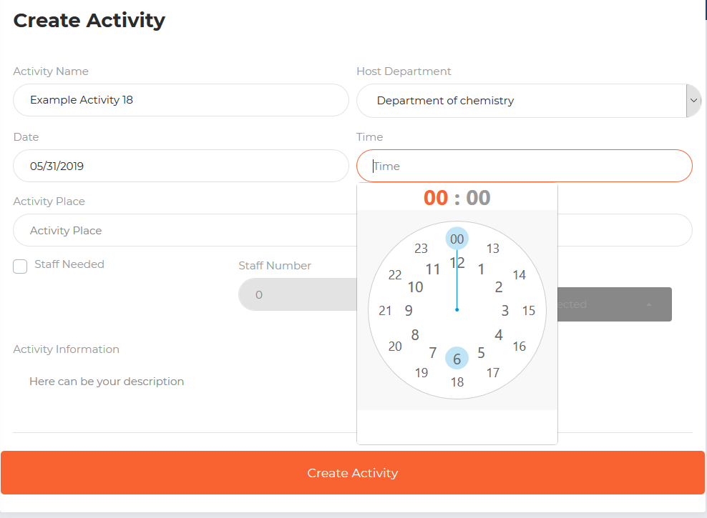

The following image, shows how to choose different categories at the same time for the new activity.

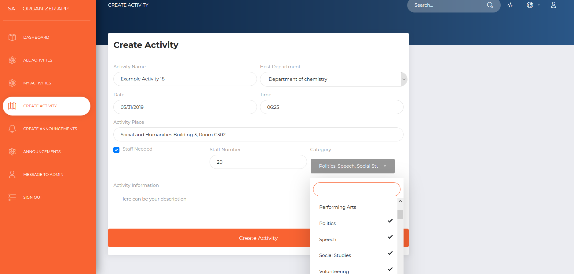

After finish filling up all the information required, click on “Create Activity” button, and automatically all information will be saved in the database and can be checked on “My activities” list.

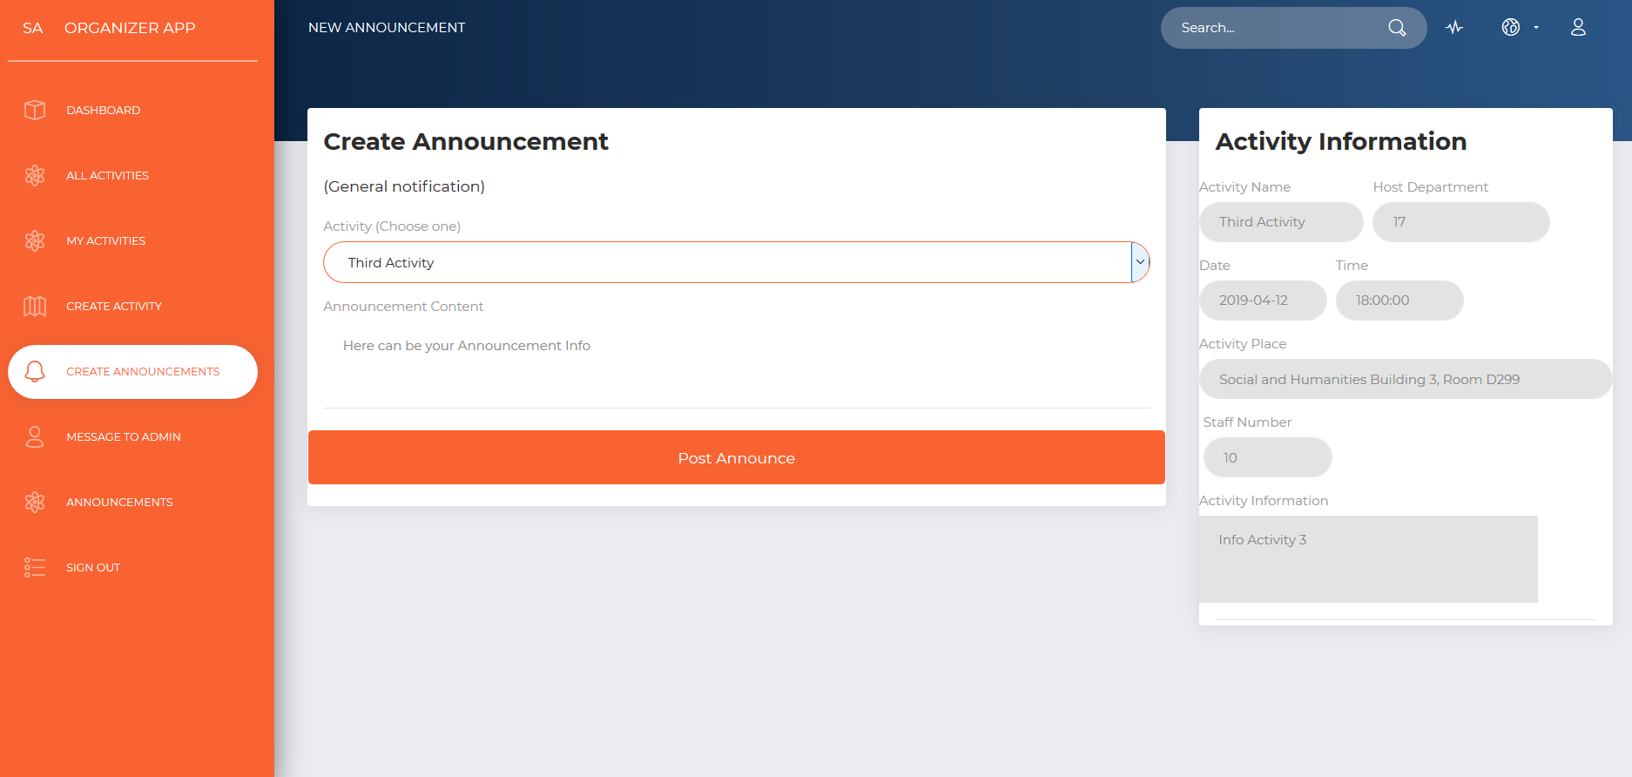

When creating an announcement, when can access to the web-page above by clicking on the menu on the left by clicking on “create announcements”. Every announcement has to be related to one activity. In order to choose an activity from the list of activities created, the user has to click on the dropdown with the name of “Activity” and after that, all the information from the activity will be displayed on the right “Activity Information” section. The last step is to write down the announcement or reminder for the activity selected from the dropdown above.

In order to see the details from any announcement, we can access directly the link in the menu on the left called “Announcements” and the list of all the announcements will be displayed on the right; and right after getting the whole list, click on any “More details” button that will takes us to the details of the activity and to the display of all the details from the announcement (as is shown below)

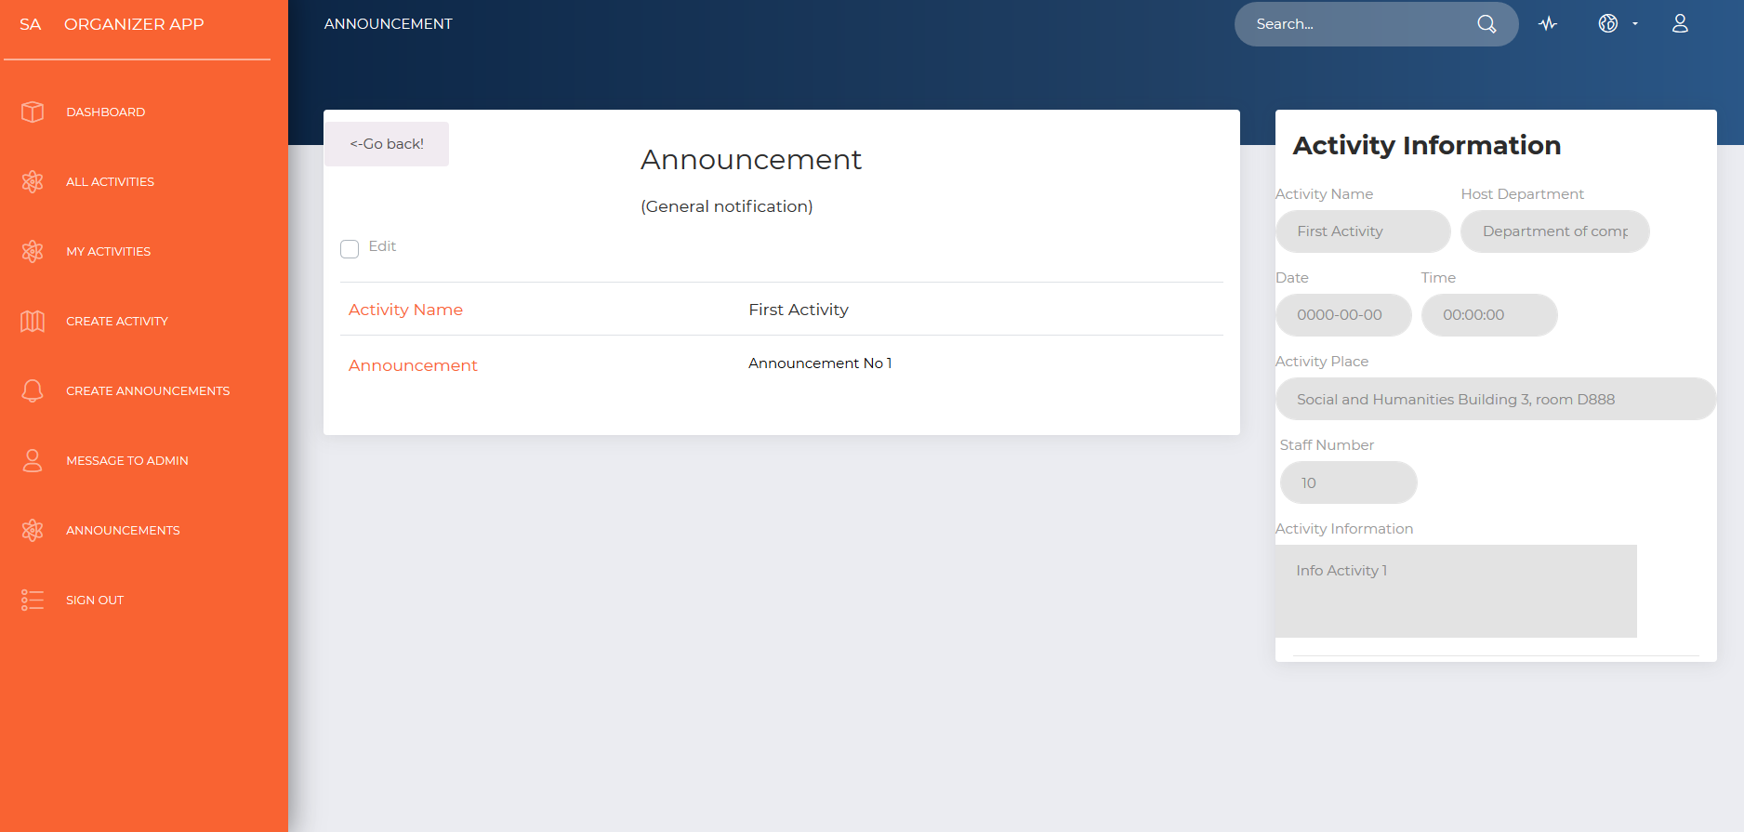

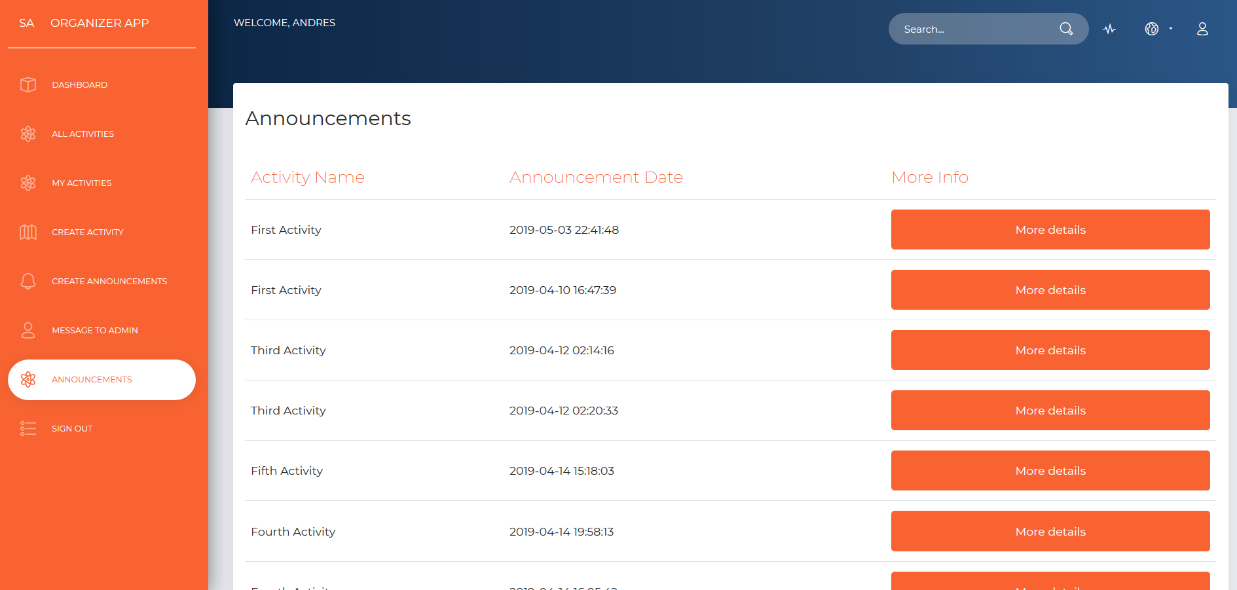

The square in red on the top left corner indicates that after checking the “Edit” checkbox, the label that contains the announcement information, will be transformed into a text area where the value can be changed, and also a light blue button at the bottom will show up to save changes. As in modifying the activity, if changes are not saved, but instead the edit checkbox is clicked for the second time, the text area will be transformed back into label with the original value in the text. Refer to the image below for more details.

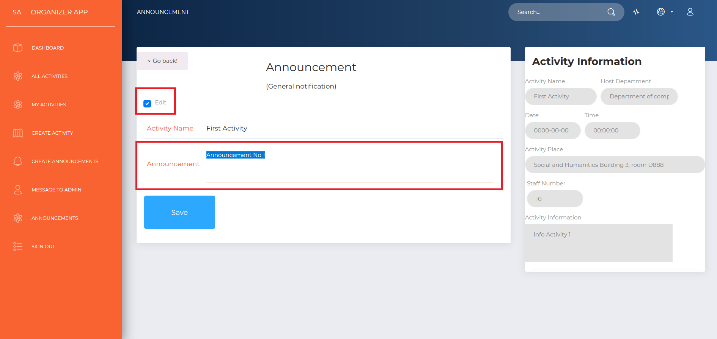

After saving changes, the web-page is refreshed with the new content for the announcement and the text area goes back to label.